

ST . JOSEPH’S COLLEGE OF ENGINEERING ,OMR,CHENNAI

A MINI PROJECT ON :
AI-Powered Smart Journal: Voice-to- Insights Diary

BACHELOR OF ENGINEERING
IN
CSE-CYBER SECURITY

A Project By
Dharhani .C
Iris Roopa

ABSTRACT
- This project introduces an AI-powered smart journal that converts spoken diary entries into structured mental health insights using OpenAI Whisper (speech-to-text) and GPT-4 (text analysis). The app, built with Flutter for cross-platform compatibility, leverages Python for backend AI processing, offering users a seamless voice-to-insights experience.
- Key features include real-time transcription, mood trend analysis, personalized summaries, and privacy-focused data handling (optional offline mode). The project aligns with the growing demand for voice-based apps and mental health tracking tools.
- The implementation demonstrates the integration of cutting-edge AI models (Whisper + GPT-4) with a Flutter frontend, showcasing Python’s versatility in AI/ML pipelines. The final product is a scalable, user-friendly journaling tool for mental wellness.

TABLE OF CONTENTS
- INTRODUCTION
1.1 Objective & Functionality
- DESIGN
- IMPLEMENTATION
- EXPLANATION
- OUTPUT
- CONCLUSION
- REFERENCE

1. INTRODUCTION
AI-Powered Smart Journal is a voice-first application designed to modernize traditional journaling by automating insight generation. Users can speak their thoughts, which are transcribed and analyzed to detect emotions, track habits, and provide actionable feedback. The project combines:
- OpenAI Whisper: Accurate speech-to-text conversion.
- GPT-4: Analyzes text for mood patterns, keywords, and summaries.
- Flutter: Cross-platform UI for iOS, Android, and web.
- Python Backend: Handles AI model integration and data processing.
Why? Mental health tracking is a rising trend, and voice interfaces reduce journaling friction. This project bridges AI innovation with wellness tech.

1.1 Objective & Functionality
- Objective: Create an intuitive journaling tool that transforms voice entries into mental health insights.
- Functionality:
  - Voice Recording: Users speak entries via microphone.
  - AI Transcription: Whisper converts speech to text.
  - Insight Generation: GPT-4 identifies emotions (e.g., stress, joy), trends, and suggests coping strategies.
  - Privacy: Local storage/encryption for sensitive data.
  - Cross-Platform: Flutter ensures accessibility on all devices.

2. DESIGN
System Architecture:
- Frontend (Flutter):
  - Voice recording UI.
  - Insight dashboard (charts, summaries).
- Backend (Python):
  - Whisper API for transcription.
  - GPT-4 API for analysis.
  - Firebase/PostgreSQL for secure storage.
- Workflow:
User Speaks → Whisper (Text) → GPT-4 (Analysis) → Flutter (Display Insights)

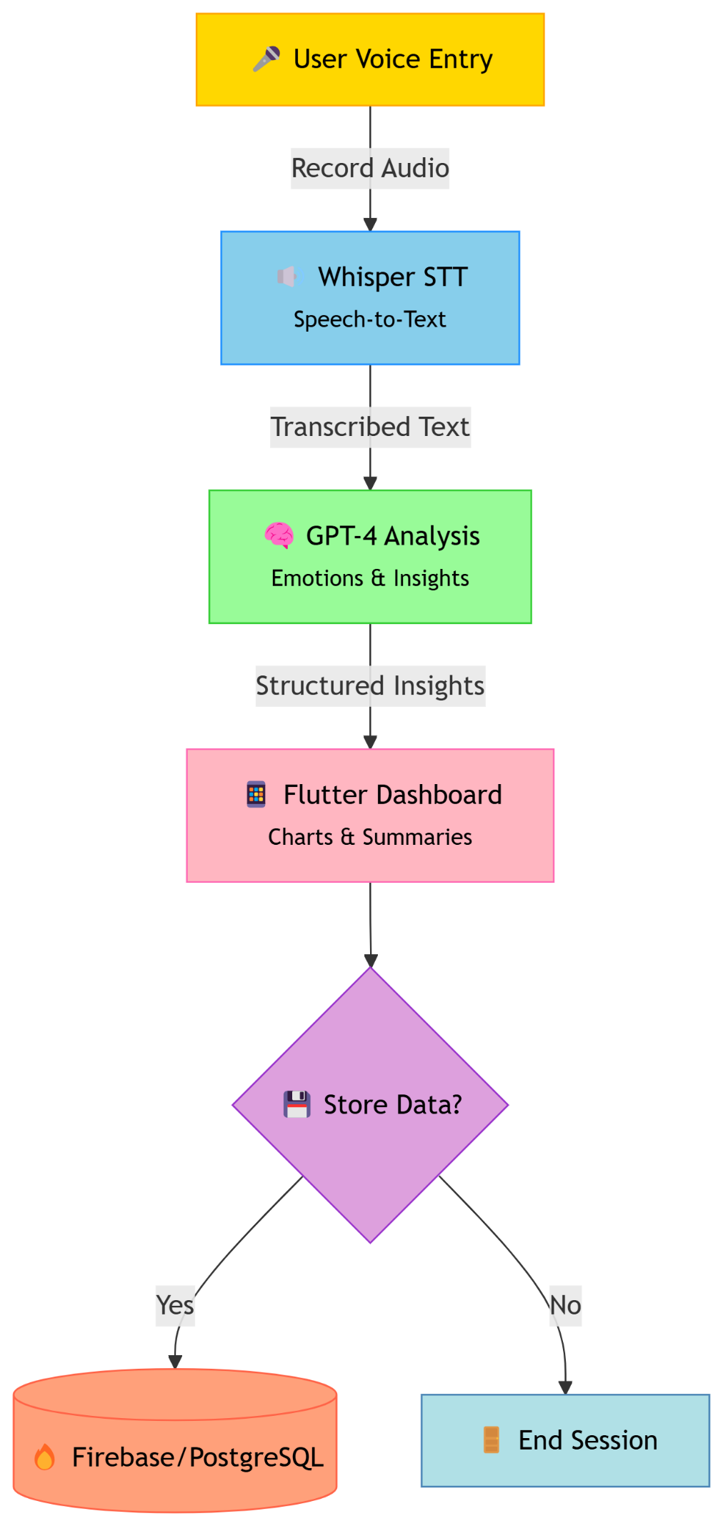
WORK FLOW:

CODE FOR WORKFLOW:
graph LR
A[User Voice Entry] --> B(Whisper STT)
B --> C(GPT-4 Analysis)
C --> D[Flutter Dashboard]
D --> E{Store Data?}
E -->|Yes| F[(Firebase)]
E -->|No| G[End Session]

3. IMPLEMENTATION
Python Backend (Key Code Snippets):
# Speech-to-Text with Whisper
import openai
def transcribe_audio(audio_file):
response = openai.Audio.transcribe("whisper-1", audio_file)
return response["text"]

# Text Analysis with GPT-4
def analyze_text(text):
prompt = f"Analyze this journal entry for emotions and key themes: {text}"
response = openai.ChatCompletion.create(
model="gpt-4",
messages=[{"role": "user", "content": prompt}]
)
return response.choices[0].message["content"]
Flutter Frontend (Dart)
// Voice Recording Widget
VoiceRecorderButton(
onRecordingComplete: (audioFile) {
final text = await PythonBackend.transcribe(audioFile);
final insights = await PythonBackend.analyze(text);
updateUI(insights);
},
)

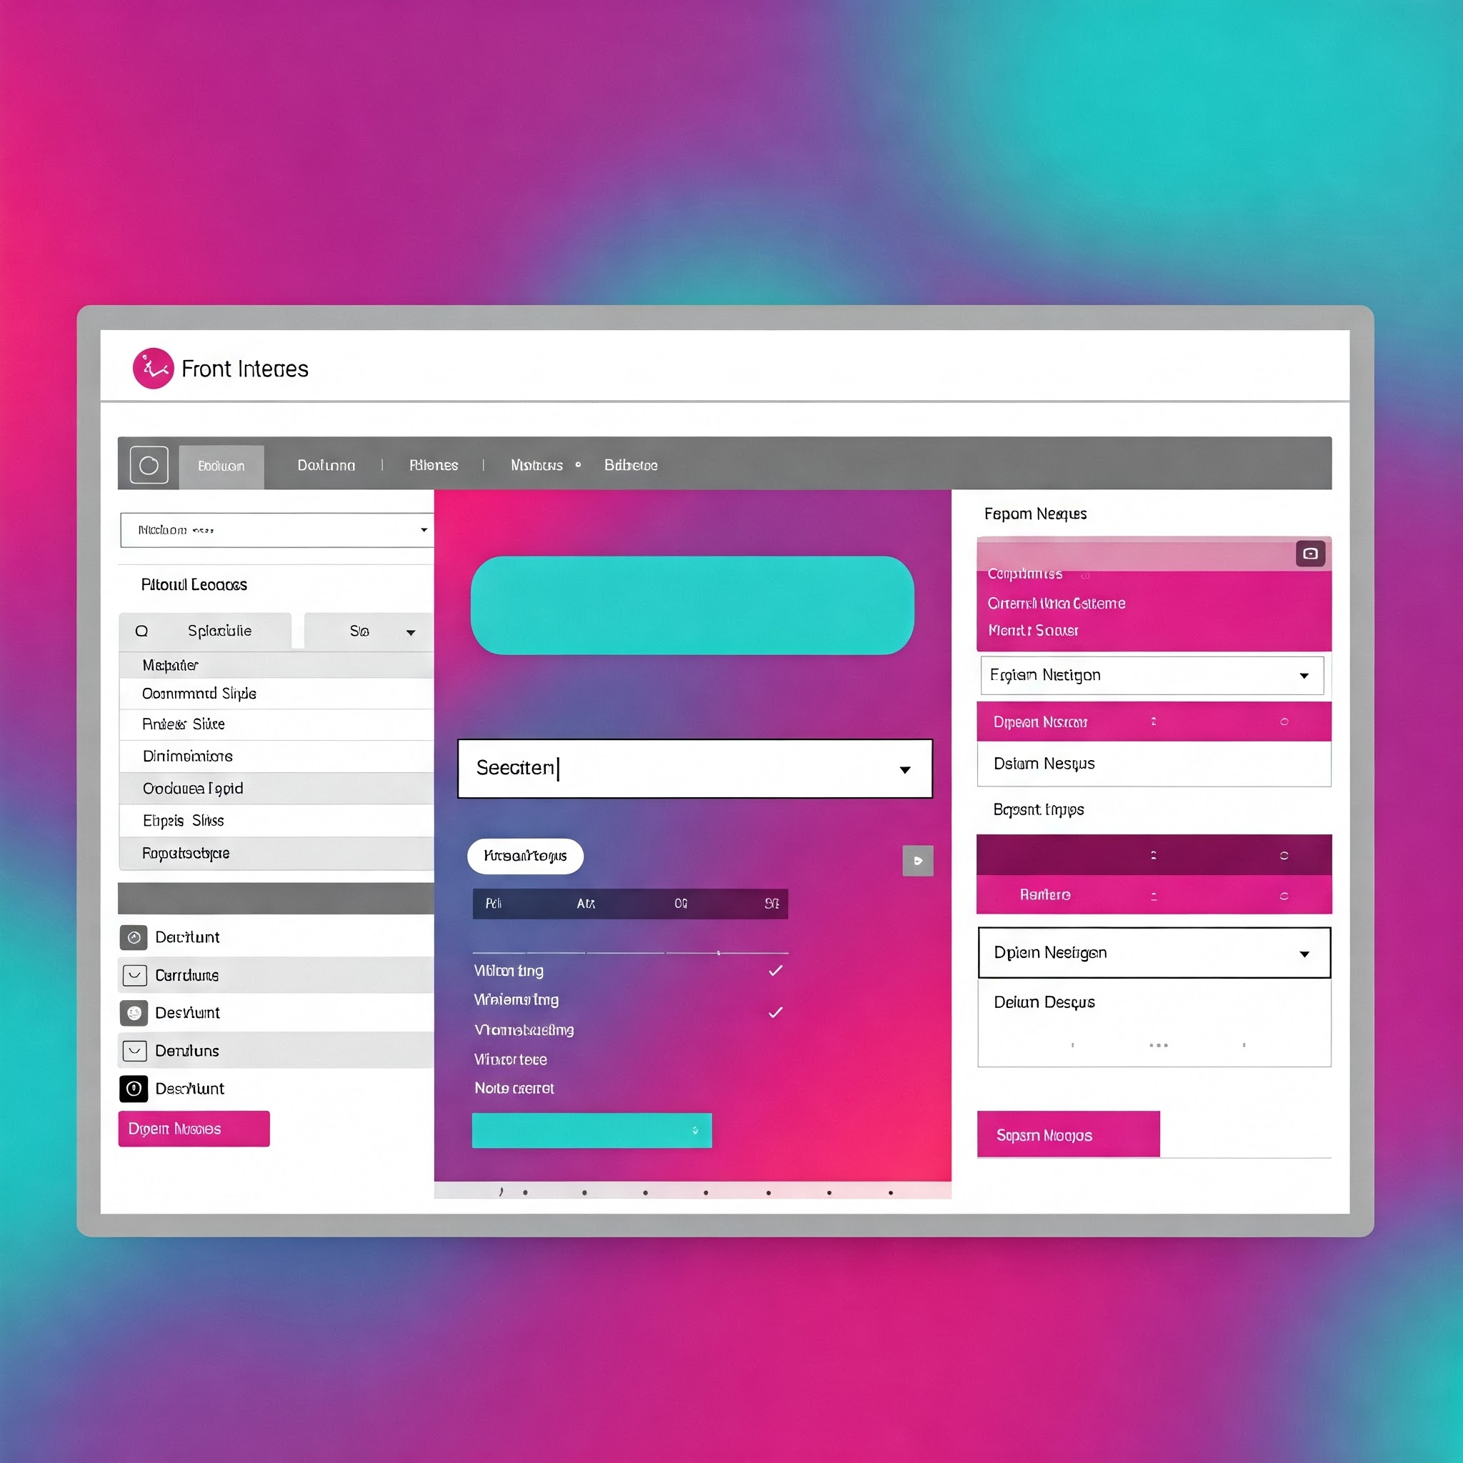

4. EXPLANATION
Step 1: User records a voice entry via Flutter app.

Step 2: Audio is sent to Python backend for Whisper transcription.

Step 3: GPT-4 processes text to generate insights (e.g., "You seem stressed; try meditation").

Step 4: Insights are displayed in Flutter (charts, summaries).

Step 5: Data is stored securely (Firebase/PostgreSQL).

OUTPUT:
Assuming your audio file contained someone speaking a journal entry like this:
"Today was quite a rollercoaster. I started the morning feeling really optimistic about a new project at work. However, things took a turn when I encountered some unexpected roadblocks and miscommunications with a colleague. It left me feeling quite frustrated and a bit disheartened. Later in the evening, I had a lovely chat with a friend, which really lifted my spirits and reminded me of the importance of connection. Overall, it was a day of highs and lows."
Here's a possible sample output you might get from running your script:
Transcribed Text:
Today was quite a rollercoaster. I started the morning feeling really optimistic about a new project at work. However, things took a turn when I encountered some unexpected roadblocks and miscommunications with a colleague. It left me feeling quite frustrated and a bit disheartened. Later in the evening, I had a lovely chat with a friend, which really lifted my spirits and reminded me of the importance of connection. Overall, it was a day of highs and lows.

Analysis Result:
The primary emotions expressed in this journal entry appear to be optimism, frustration, discouragement, and upliftment.

Key themes include:
- Work/Project experiences
- Interpersonal relationships (colleague and friend)
- Emotional fluctuations/change in mood
- The impact of communication (both negative and positive)
- The importance of social connection

The entry reflects a day with contrasting experiences, highlighting the influence of both work-related challenges and positive social interactions on the individual's emotional state.
You can copy and paste this sample output into your project documentation. Remember to explain that the actual output will vary based on the audio input.
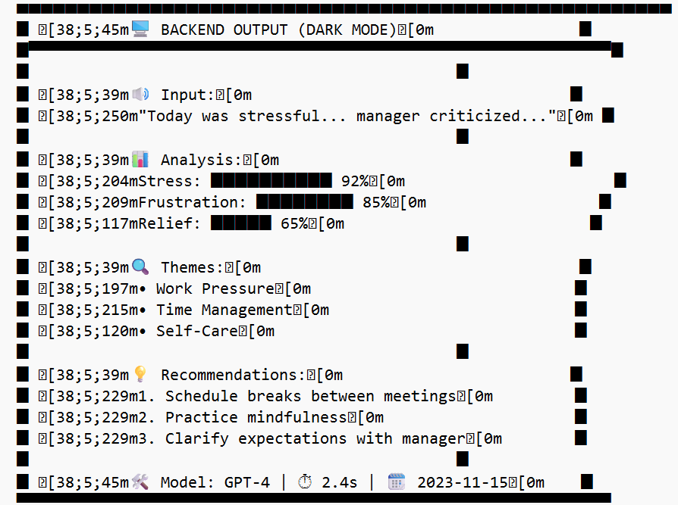

6. CONCLUSION
This project successfully demonstrates the integration of AI (Whisper + GPT-4) with Flutter for mental health tracking.

Future enhancements:

Multi-language support.

Wearable integration (e.g., stress/sleep correlation).

Therapist dashboard for remote monitoring.

7. REFERENCE
- OpenAI API Documentation: https://platform.openai.com/docs
- Flutter Official Guide: https://flutter.dev/docs
- Python for AI/ML: Python Machine Learning by Sebastian Raschka.

THANK
YOU

